1. 
2. **Scenario**: When we download a file, after downloading the file, we want to kick off another thread to scan the downloaded file for viruses. Scanning a file is time consuming task. But scanning thread should run after the downloading thread has finished. How to know that downloading thread has finished? Downloading thread can take some seconds, some minutes or longer.
3. **Solution**: To solve this problem, we should use “Joining the Thread”. 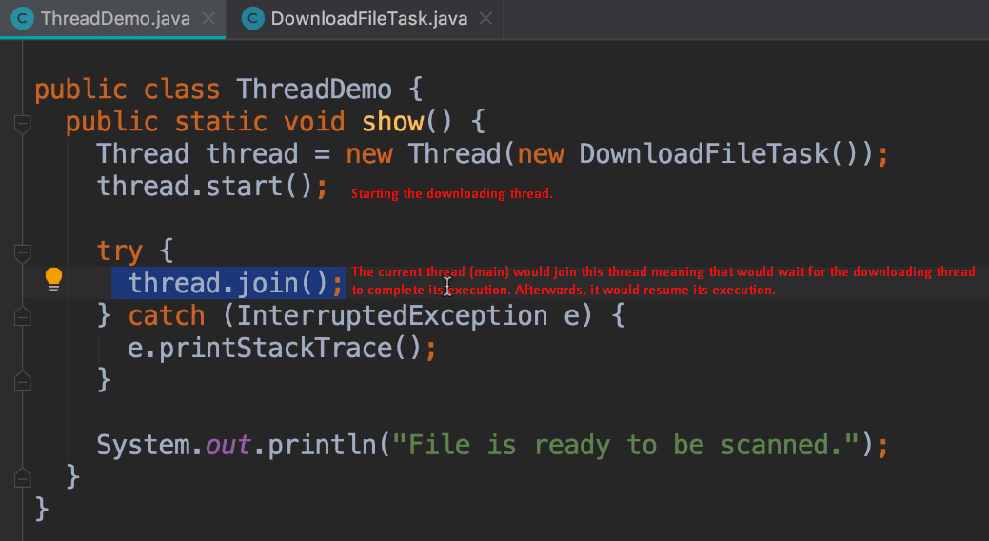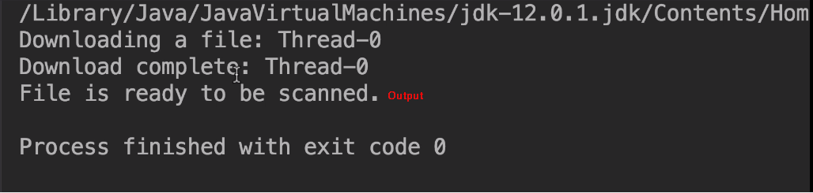
4. **Problem:** If main method in desktop or mobile app is responsible to GUI actions by users, user would not be attended by the main thread as it is waiting for other thread to finish. So, bad user experience.  
   **Jatin**: It doesn’t mean join() method should not used. Actually, the strategy is not good here. ☺